**Kadayawan Festival**

Once a small gathering, Kadayawan Festival in Davao is now one of the highly-anticipated festivals in the Philippines. From the dynamic street dancing to the vibrant giant floral parade, Kadayawan has something for everyone!

Held every third week of August, Dabaweños celebrate Kadayawan Festival as a thanksgiving event and a tribute to the lumad, a collective group of indigenous people living in the city. This is what makes Kadayawan a unique festival.

**Kadayawan Festival History**

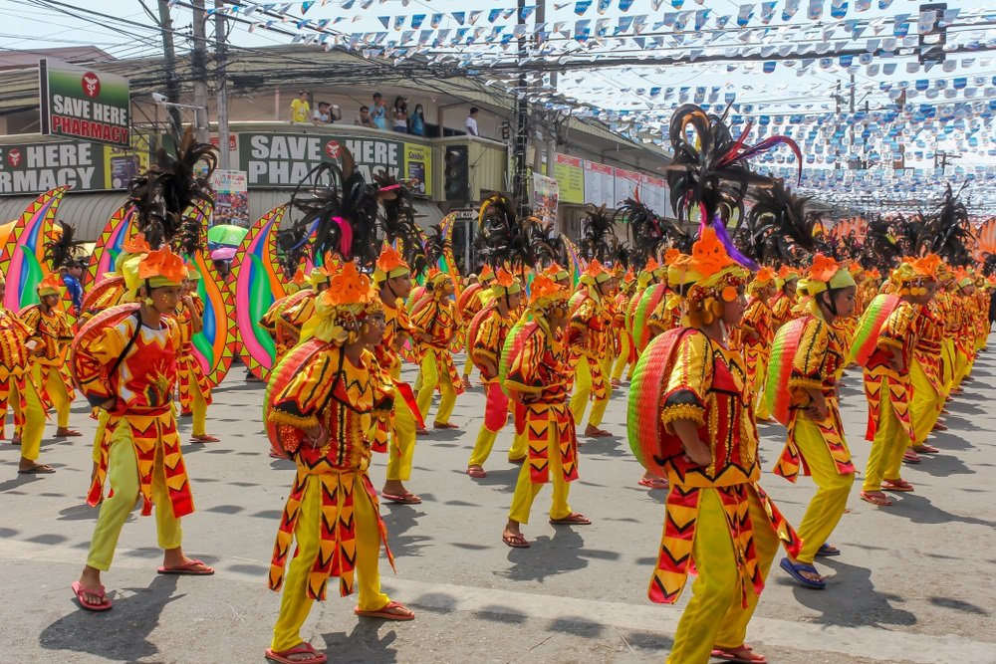

Kadayawan is a native expression in the Dabawnon tongue. It’s derived from the word “madayaw” which means good, valuable, and superior. Hence, Kadayawan Festival Tagalog means pasasalamat at pagpapahalaga. It is the celebration of life, a thanksgiving for the gifts of nature, the wealth of culture, and bounties of harvest and serenity of living.

While it’s celebrated without the religious factor, the origin of Kadayawan Festival is the pagan belief of the ethnic tribes of Davao. Back in the day, the ethnic tribes would come together at the foot of Mt. Apo, the Philippines’ highest mountain, to celebrate abundant crops, performing rituals that paid tribute to the nature gods Manama and Bulan.

As a sign of respect for the great year they’ve had, they displayed fruits, vegetables, flowers, rice, and corn grains on their mats and at the front of their houses. They also used to sing and dance as well, much like what they do today.

In the 1970s, then-Mayor Elias B. Lopez, encouraged the Davao ethnic tribes to showcase their thanksgiving rituals. In 1986, the Davao City government launched a project that aimed to unite the people during the turbulent times of the Martial Law.

That time, the festival was called Apo Duwaling, named after three natural wonders you can find the region: Mt. Apo, Durian, and Waling-waling. It was officially renamed as the Kadayawan Festival in 1988 by then-Mayor Rodrigo Duterte.

**Kadayawan Festival Activities You Must Not Miss**

Each year, Kadayawan Festival becomes bigger and grander! So you can’t blame us for looking forward to Kadayawan Festival 2020 happenings! Here are some activities you shouldn’t miss in the festival.

**1. Indak Indak sa Kadalanan (Street Dancing)**

The Kadayawan Festival dance on the streets is the most-awaited and main highlight of the event. Contingents from various parts of Mindanao display their award-winning choreography while showcasing their creativity through their colorful and extravagant Kadayawan Festival dance costumes!

**2. Pamulak Kadayawan (Kadayawan Floral Parade**

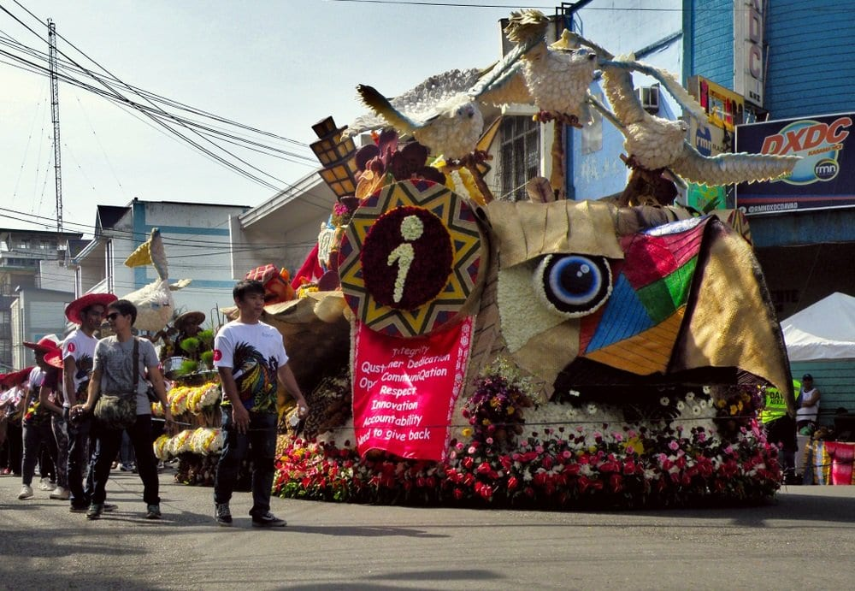

Another thing to look forward to Kadayawan Festival 2020 is the Pamulak Kadayawan. It is like the Panagbenga Festival in Baguio and the Pasadena Parade of Roses in the United States where flowers and fruits are set in colorful floats by business establishments, community assemblies, and peoples’ organizations as they parade on the streets symbolizing all the bounty sustainably enjoyed by the city’s residents.

**3. Hiyas ng Kadayawan**

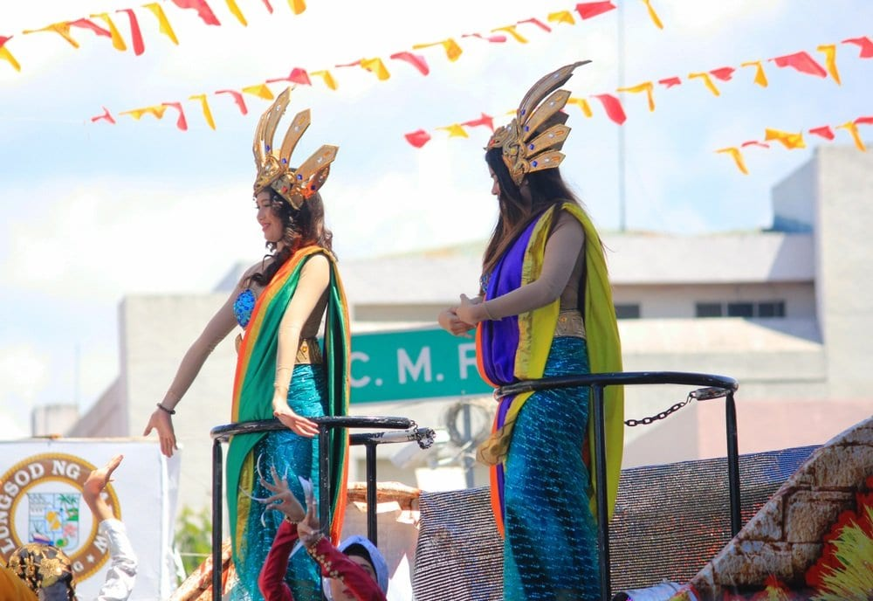

A festival will not be complete without a beauty pageant. In Davao, they have the Hiyas ng Kadayawan, one of the most-awaited events in the festival. What makes this pageant different from others is its aim to promote and make people embrace their culture. This is a quest for a young woman who understands her culture and traditions.

**4. Shopping in the Kadayawan Agri-Trade Fair**

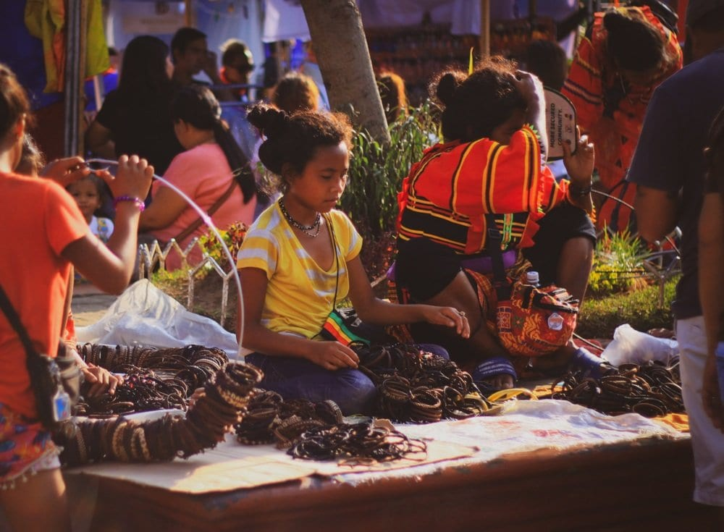

Since you’re already in Davao to discover more of their culture, you might as well make the most out of it by checking out the Kadayawan Agri-Trade Fair where various fruits and crops, plants, and furniture are set up in commercial stalls for visitors to purchase. There are also handicrafts, accessories, and colorful malong (traditional clothing) that are up for grabs in the local market.

**5. Trying Davao’s famous Durian**

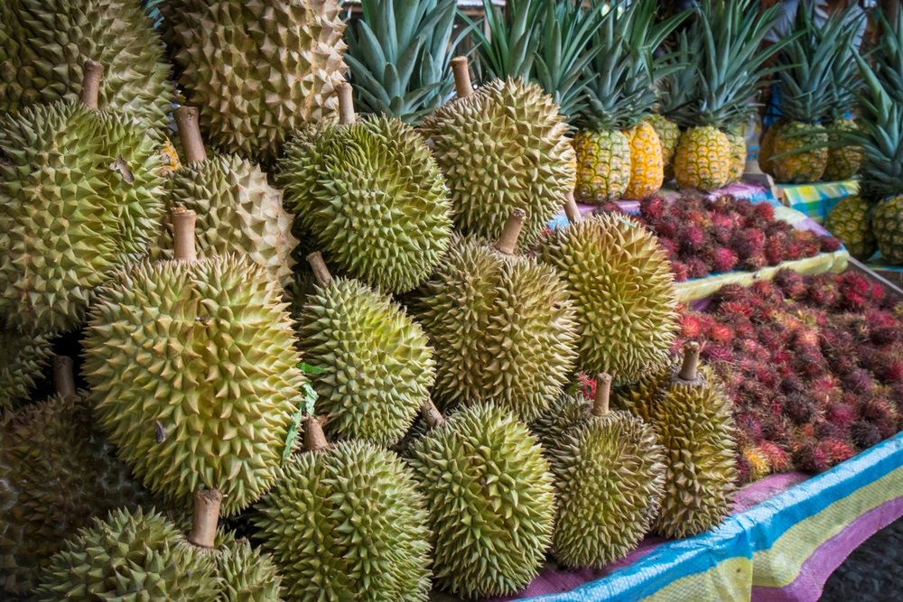

Dubbed as the “Durian Capital of the Philippines,” you can taste the most delicious durian only in Davao! Some tourists don’t like it because of its bad smell but don’t let it fool you. While it does not smell that good, it tastes great! But if you can’t still stand its smell, you can just try the durian candies that won’t fail you. Among the famous fruits you can try, too, in Davao are the mangosteen, lanzones, and rambutan that are sold cheap by the way! Perfect for pasalubong.

**6. Dula and Sayaw Kadayawan**

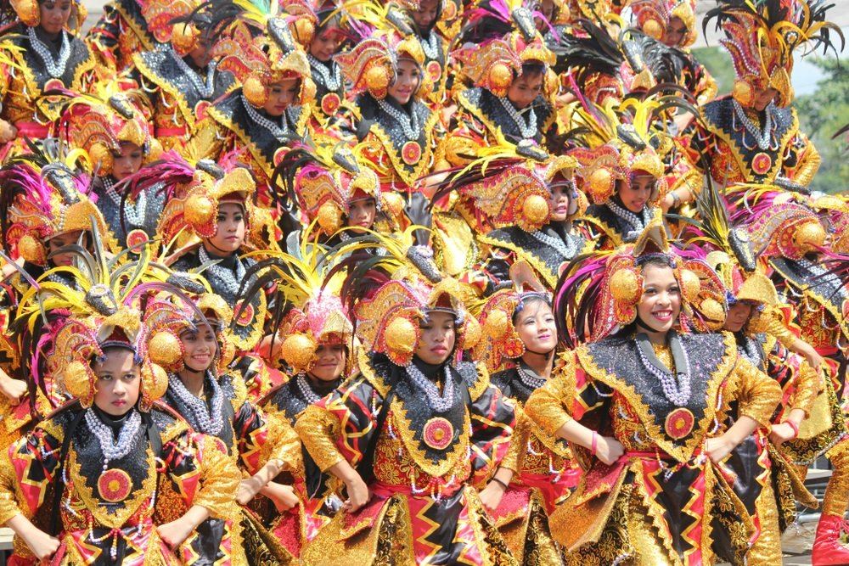

Prepare to experience a fascinating activity by engaging with the local tribes through their unique games. Afterward, witness a program highlighting the traditions and folklore of the 11 tribes through creative dances.

**8. Immersing on Davao’s ethnic origin at Kadayawan Village**

Because Kadayawan Festival Tagalog celebrates the ethnic groups, life, culture, and traditions, your trip will be more meaningful if you learn more about those things. You can visit the Kadayawan village that gives the visitor a glimpse of the thriving culture of the 11 tribes of Davao.

*Source: zenrooms.com*